**CLASSIFICATION => Discrete Set of categories/Classes**

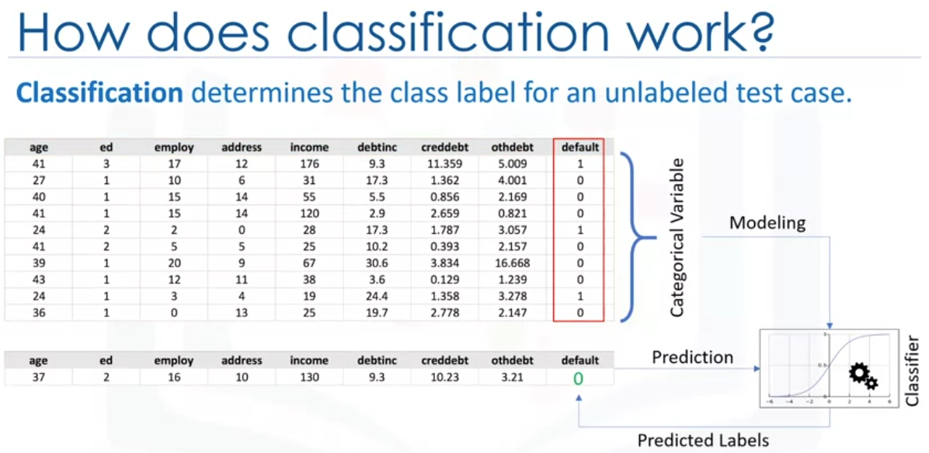

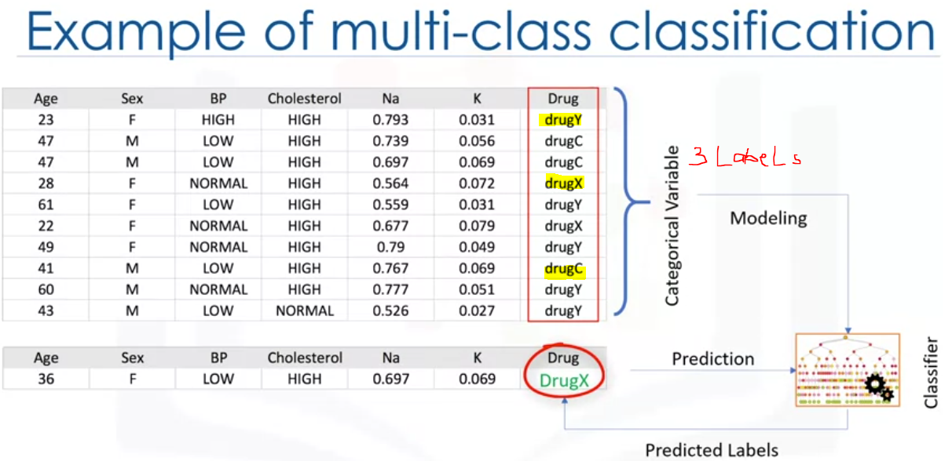

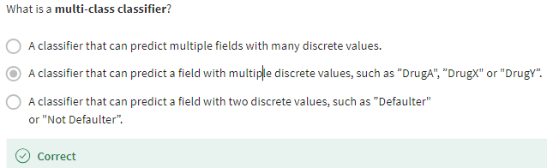

**KNN (K-Nearest Neighbor)**

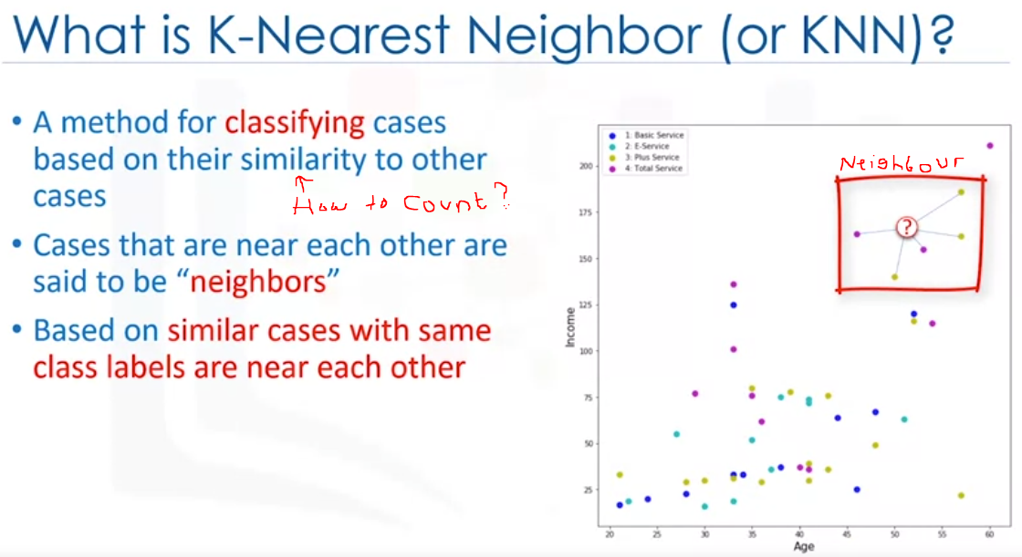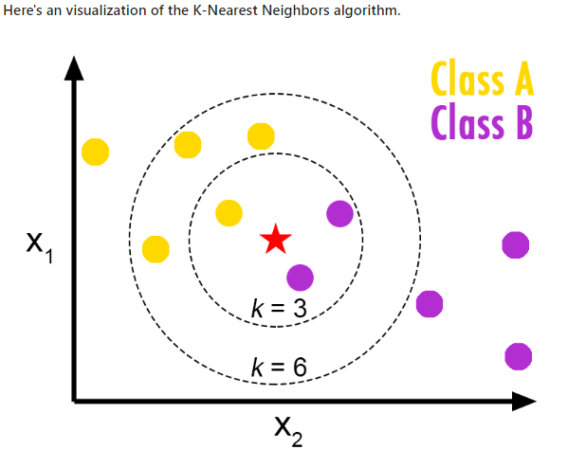

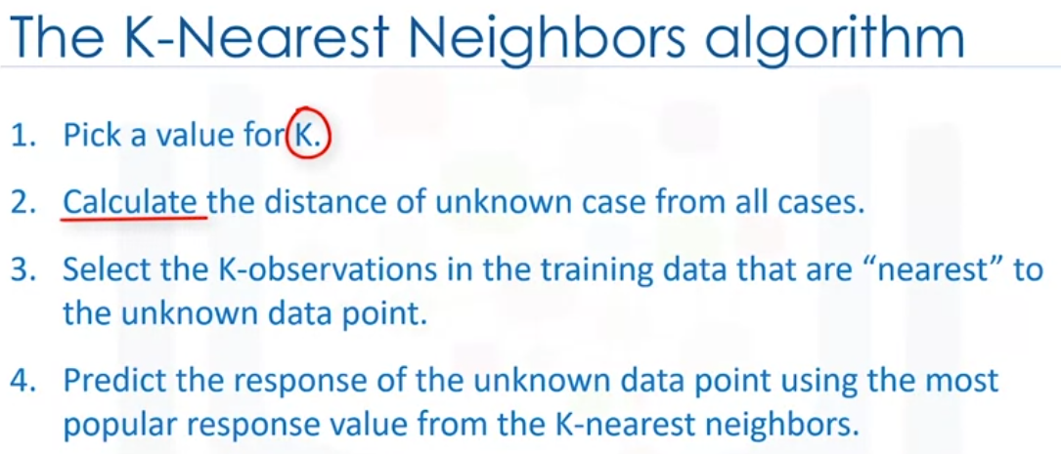 

 

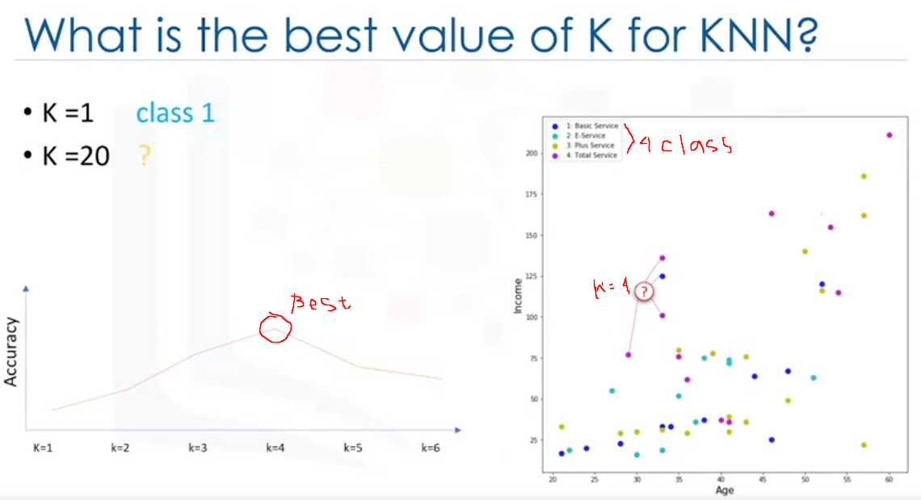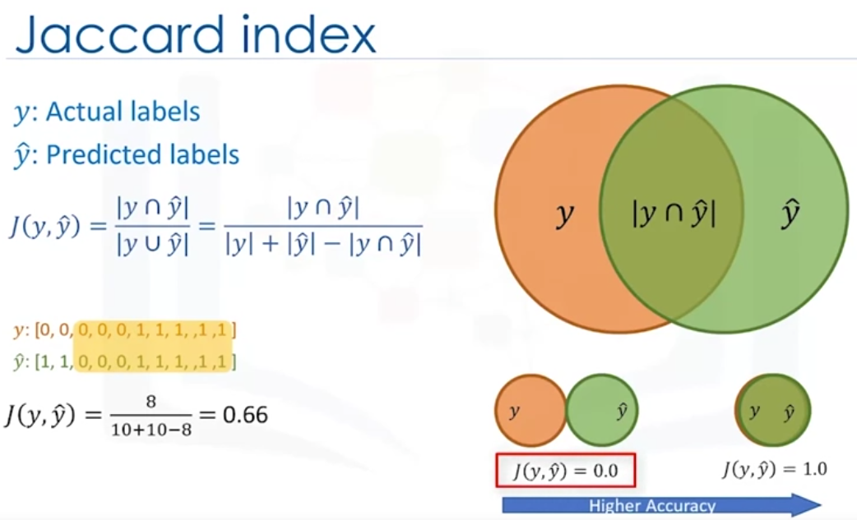

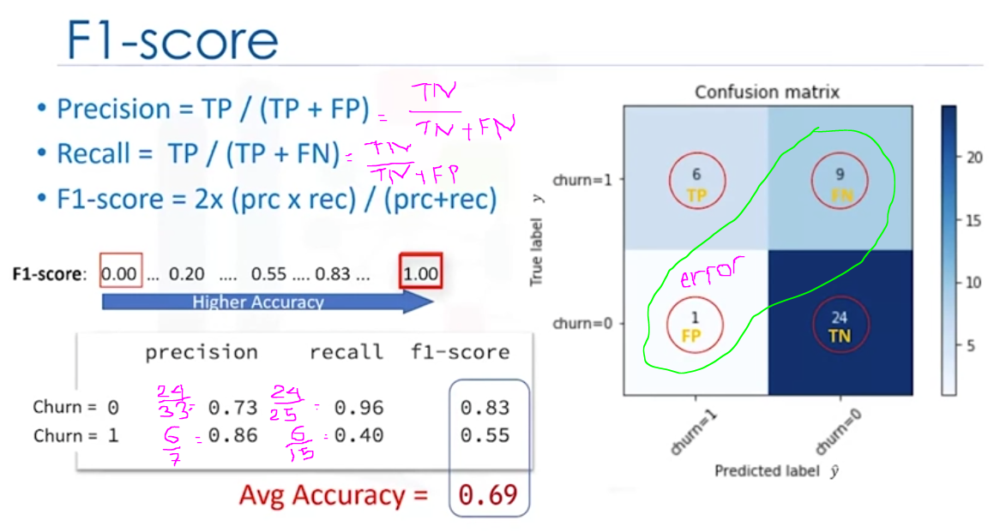

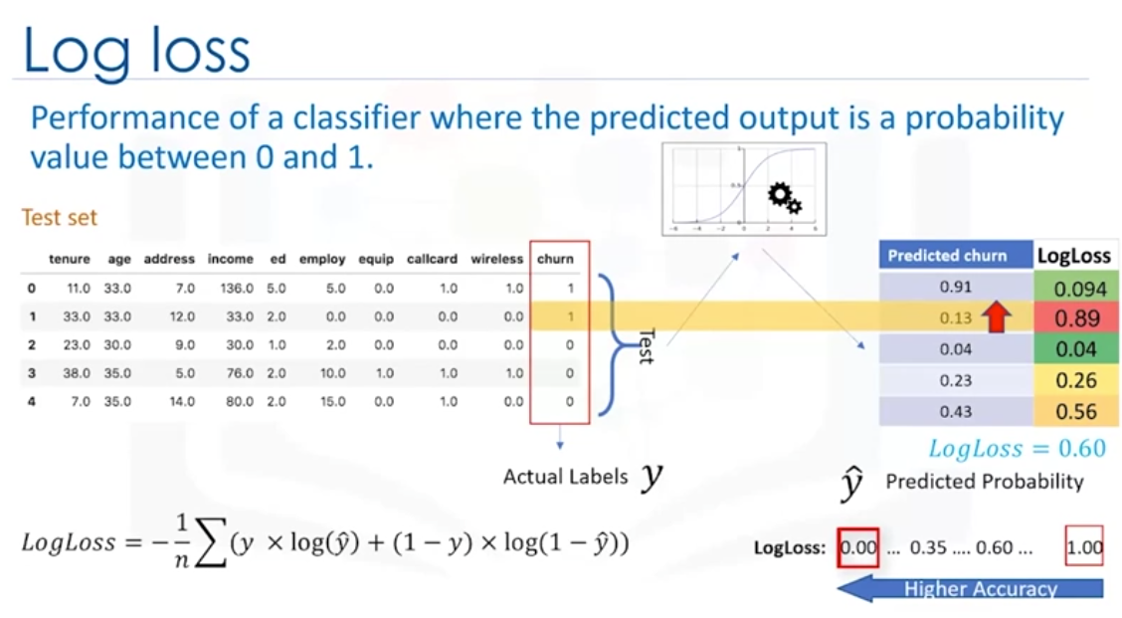

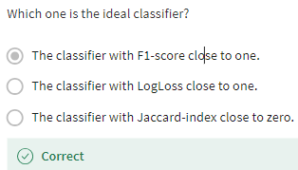

KNN Steps :

1. Load datasets : df = pd.read_csv(‘nama_file.csv’)
2. Data Visualization & Analysis (Exploration data analysis)

* df['custcat'].value_counts() #how many of each class is in our data set **#Custcat : dependant variable**
* df.hist(column='income', bins=50) #income is independent variable with Histogram
* df.columns #Check features in Columns

1. Define Feature Set

* X = df[['region', 'tenure','age', 'marital', 'address', 'income', 'ed', 'employ','retire', 'gender', 'reside']] .values #.astype(float) #convert from pandas dataframe to Numpy array
* y = df['custcat'].values **#Custcat : dependant variable**

1. Normalize Data using Standard Scaler #get Zero mean and unit variance

* X = preprocessing.StandardScaler().fit(X).transform(X.astype(float))

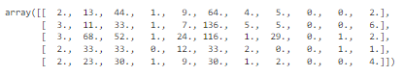 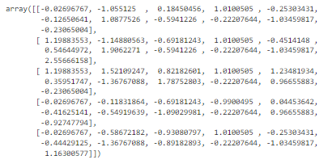

1. Train Test Split

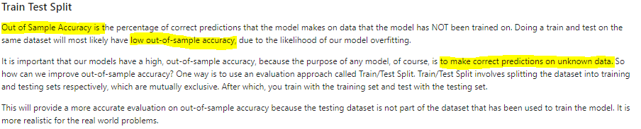

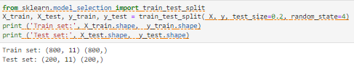

Using train_test_split from sklearn, with 80/20 train-test, with X & Y **from define feature set**

1. **KNN MODEL**

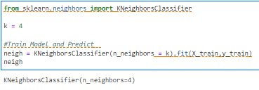

1. Predicting

* yhat = neigh.predict(X_test) #y0 actual values, and yhat predicted values
* yhat[0:5]

1. Evaluation (Accuracy)

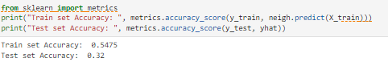

1. Compare with others number of K,, ie. K=6 compare with K=4.. ***K>> does not means higher accuracy***

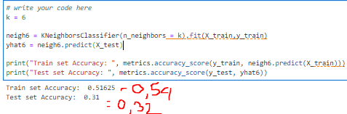

1. Or we can try with others method with different numbers of K, compare with accuracy.

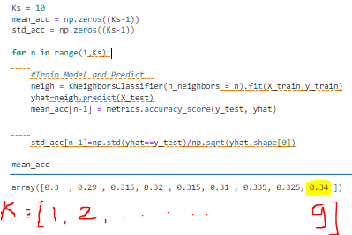

1. Plot Various with different numbers of K

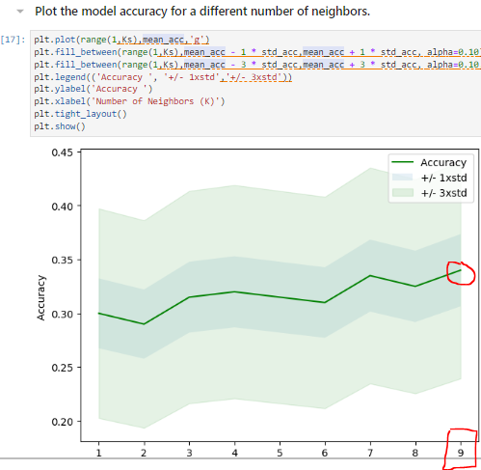

print( "The best accuracy was with", mean_acc.max(), "with k=", mean_acc.argmax()+1)

* The best accuracy was with 0.34 with k= 9

**DECISION TREEs => to map out all possible decision paths in the form of a tree**

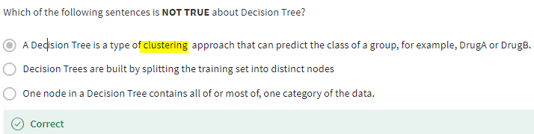

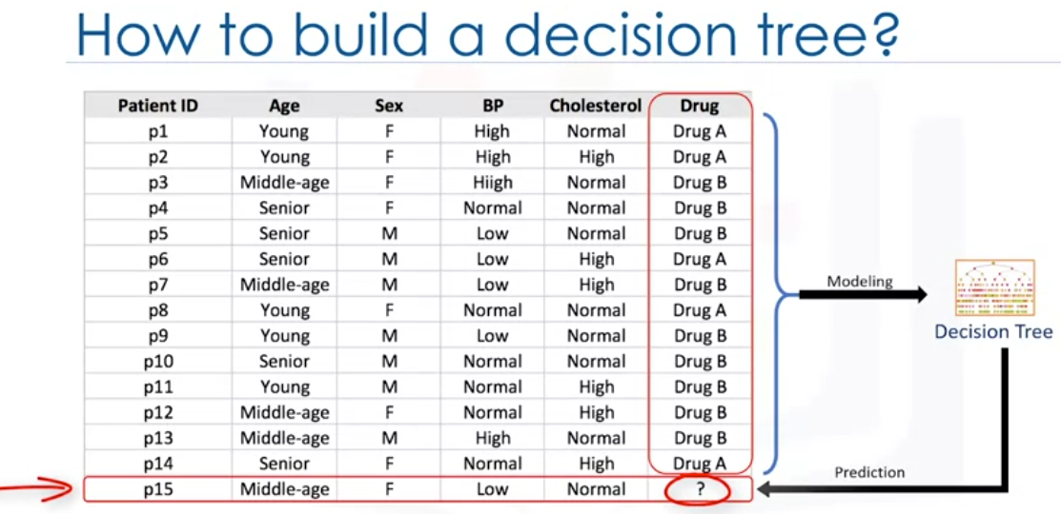

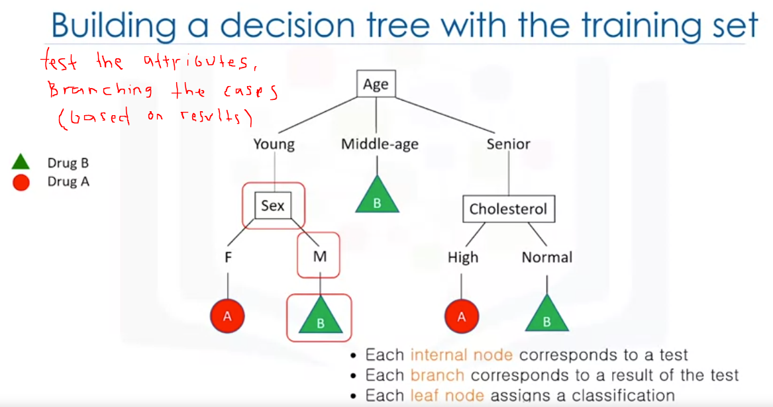 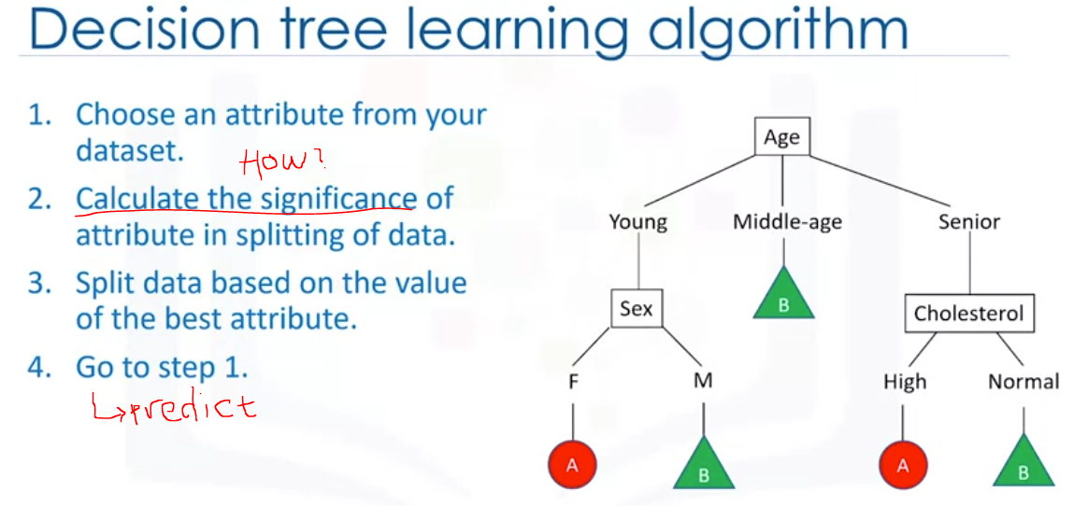

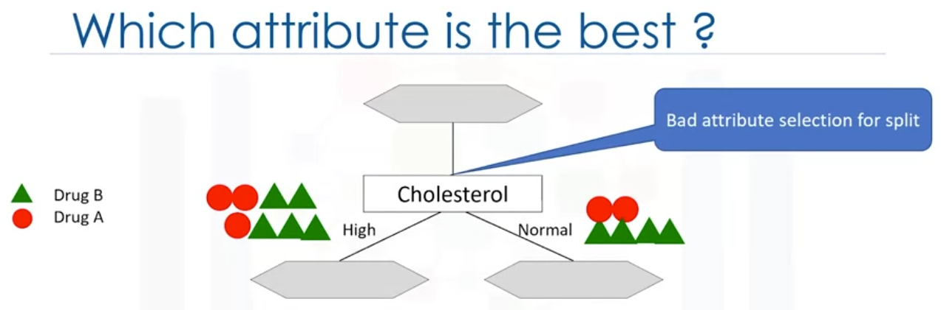 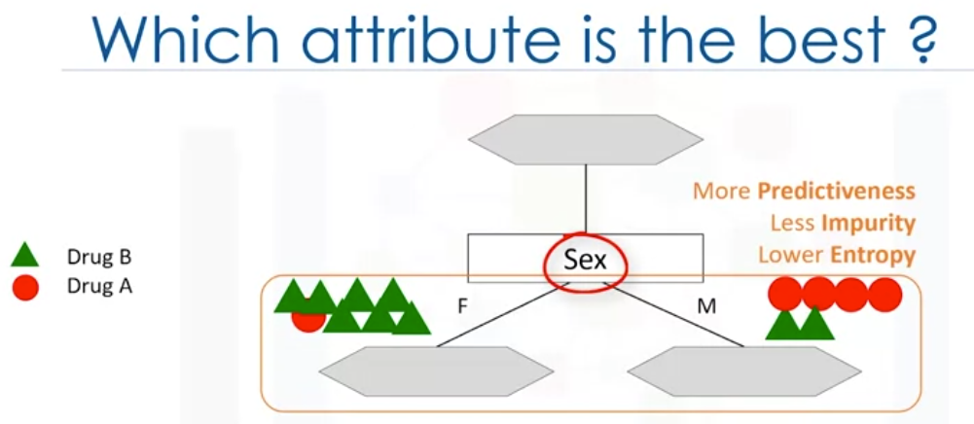

Sex attributes good candidate compare to Cholesterol attribute, entropy is amount of information disorder.

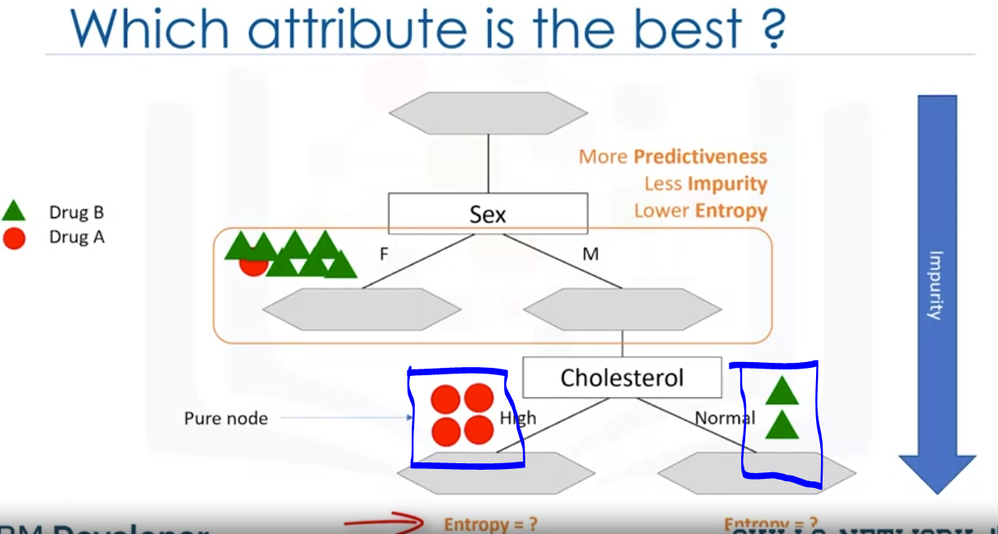 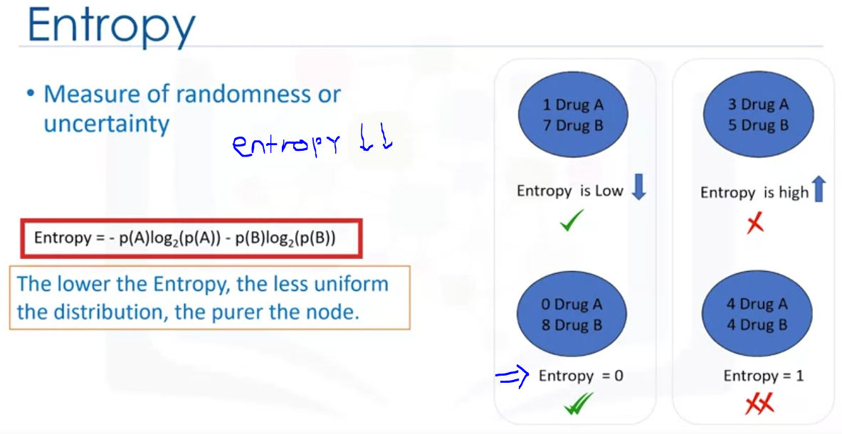

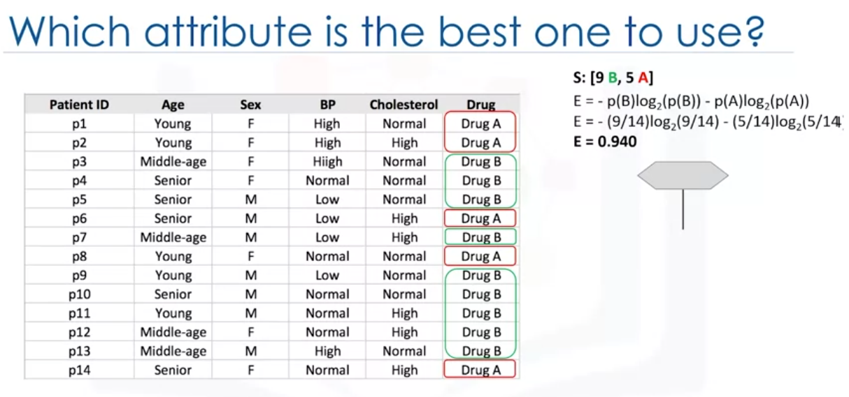

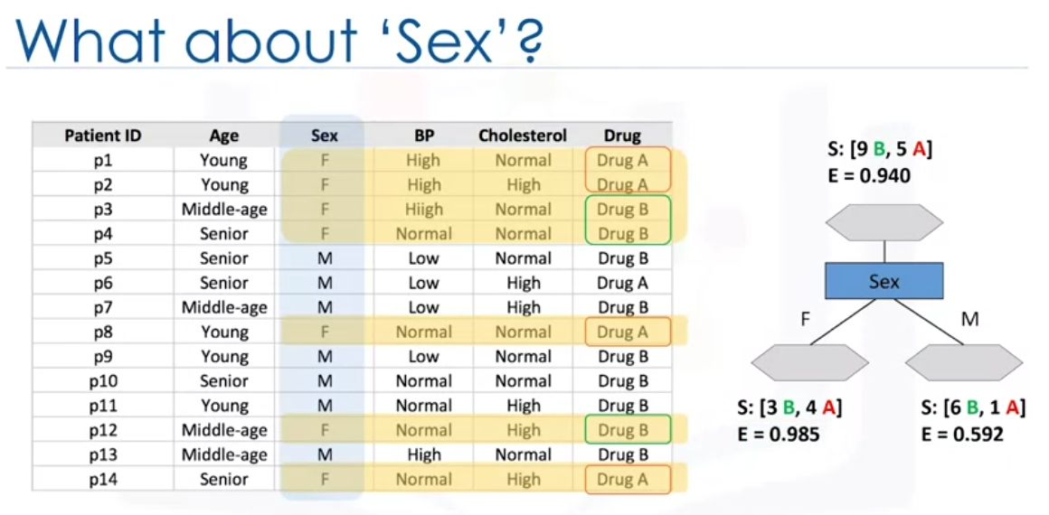 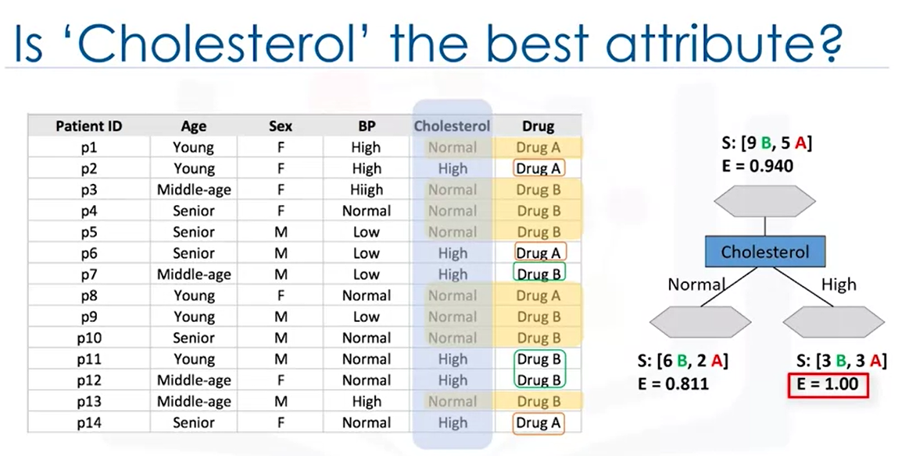

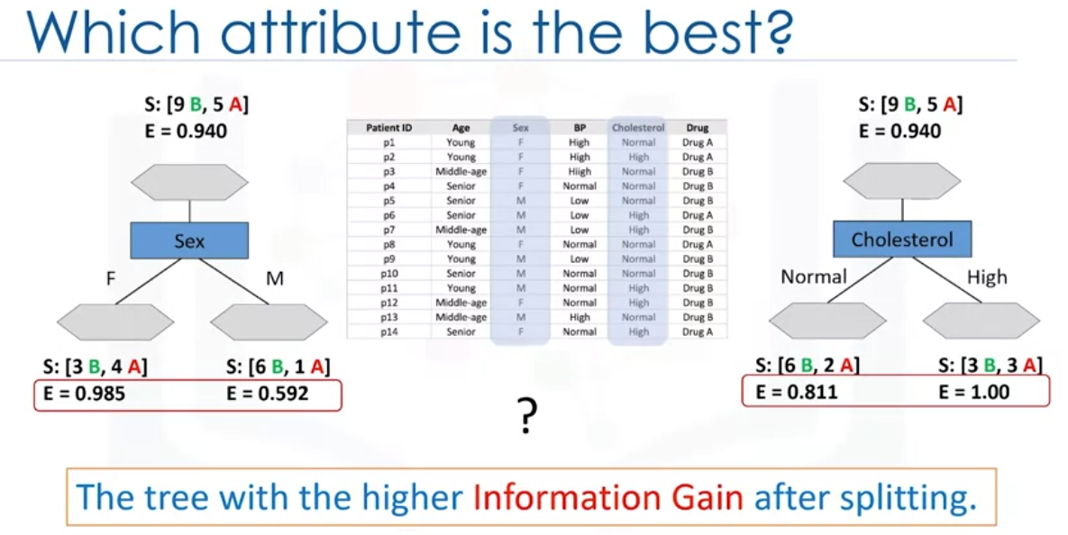

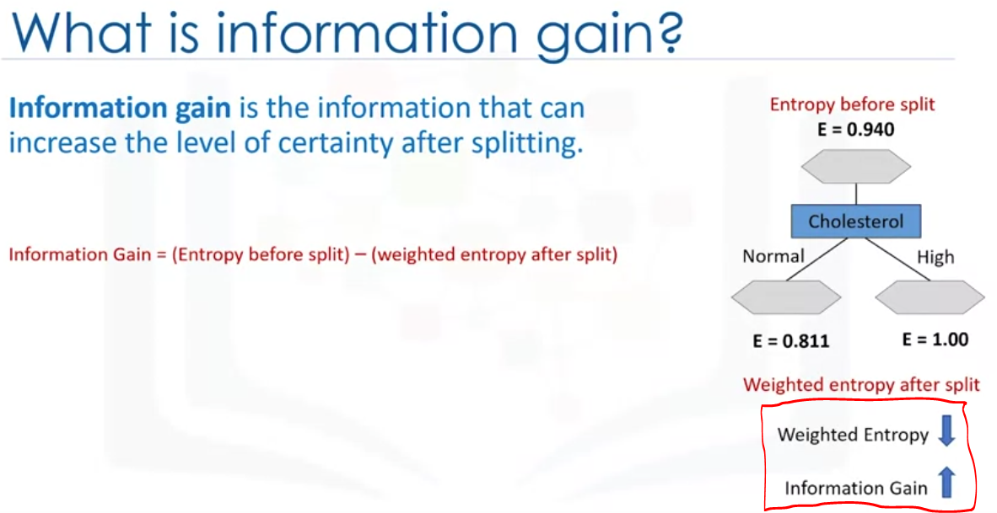

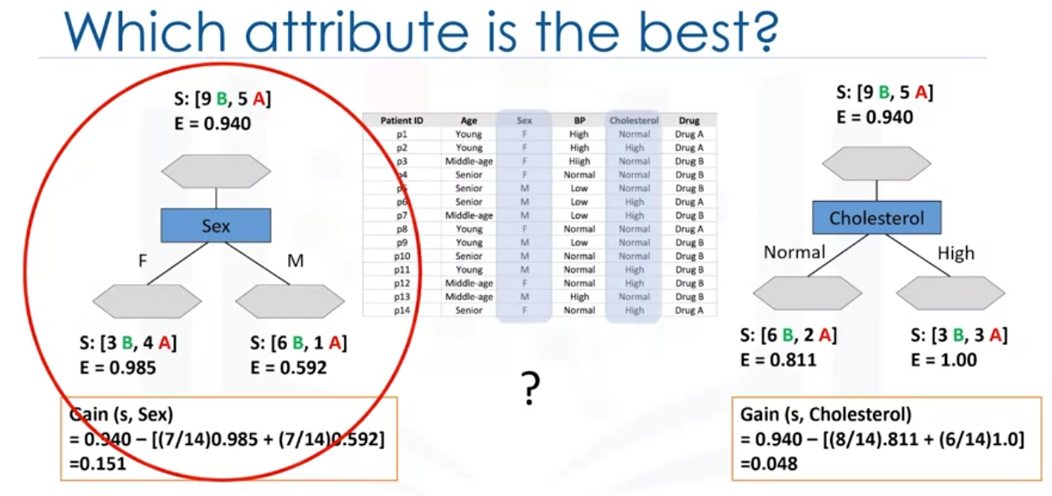

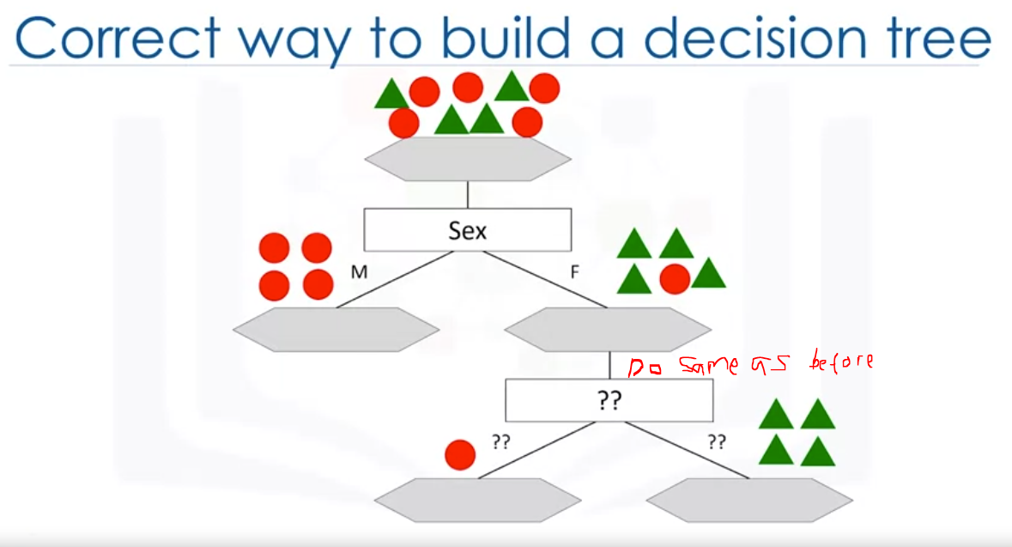

Decision Tree :

1. Download dataset : my_data = pd.read_csv(‘nama_file.csv’)
2. Pre-processing (Define Feature Set), X= Feature and Y as target or dependant variable

* X = my_data[['Age', 'Sex', 'BP', 'Cholesterol', 'Na_to_K']].values # Remove the column containing the target name (Drug)
* y = my_data["Drug"] #y is target or dependant variable
* Sklearn Decision Trees does not handle categorical variables. We can still convert these features to numerical values using the LabelEncoder() method to convert the categorical variable into dummy/indicator variable

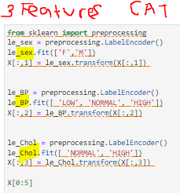

* Asdas
* sadasd

1. Setup the Decision tree Model

from sklearn.model_selection import train_test_split

* X_trainset, X_testset, y_trainset, y_testset = train_test_split(X, y, test_size=0.3, random_state=3)
  + **X** and **y** are the arrays required before the split, the **test_size** represents the ratio of the testing dataset (70%-30%), and the **random_state** ensures that we obtain the same splits.
  + Print the shape of X_trainset and y_trainset. Ensure that the dimensions match.

print('Shape of X training set {}'.format(X_trainset.shape),'&',' Size of Y training set {}'.format(y_trainset.shape))

* + Also check shape of X_testset and y_testset, must MATCH

print('Shape of X training set {}'.format(X_testset.shape),'&',' Size of Y training set {}'.format(y_testset.shape))

1. Modelling, create Classifier

* drugTree = DecisionTreeClassifier(criterion="entropy", max_depth = 4)

drugTree # it shows the default parameters

1. Train the model

* drugTree.fit(X_trainset,y_trainset) # Fit in Trainset (X, Y)

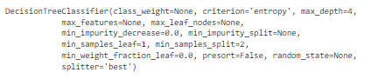

1. Prediction, using Test set (X_testset)
2. Printout Prediction Tree y_testset compare with actual values

* print (predTree [0:5])

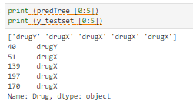

* print (y_testset [0:5])

1. Evaluation

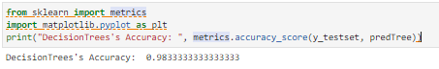

1. Visualization TREE

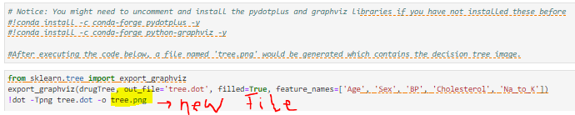

In Classification, we can use decision tree. The purpose of decision tree are to minimize Weighted Entropy but to increase information gain. Entropy is amount of information disorder. But for regression, commonly called regression trees. The basic idea behind regression trees is to split our data into groups based on features, like in classification, and return a prediction that is the average across the data we have already seen. In Regression Trees, we choose features that minimize the error. A popular one is the Mean Absolute Error (MAE).

1. Read dataset : data = pd.read_csv(‘ ….csv’)
2. Check NAN Values : data.isnull().any() #you can find just the columns that have NaN value

Or data.isna().sum()

1. Pre Processing – drop NAN Values : lets drop the rows with missing values

data.dropna() #drop all rows that have any NaN values

#from 506 rows × 13 columns to 394 rows × 13 columns,, then check NAN Values from Number 2.

1. Split the dataset into our features and what we are predicting (target)

X = data.drop(columns=["MEDV"]) # 394 rows × 12 columns

Y = data["MEDV"] #dengan columns MEDV as target

1. Split our data into a training and testing dataset using train_test_split from sklearn.model_selection

X_train, X_test, Y_train, Y_test = train_test_split(X, Y, test_size=.2, random_state=1)

1. Create Regresion Tree using Decision Tree Regressor from sklearn.

regression_tree = DecisionTreeRegressor(criterion = 'mse')

1. lets train our model using the fit method on the DecisionTreeRegressor object

regression_tree.fit(X_train, Y_train)

1. Evaluation using score (R2) indicates coefficients of determination

regression_tree.score(X_test, Y_test)

1. We can also find the average error in our testing set which is the average error in median home value prediction

prediction = regression_tree.predict(X_test)

print("$",(prediction - Y_test).abs().mean()*1000)

-------------------------------------------------------------------------------------------------------------------------------------

1. Train a regression tree using the criterion mae then report its 𝑅2 value and average error

regression_tree = DecisionTreeRegressor(criterion = "mae")

regression_tree.fit(X_train, Y_train)

print(regression_tree.score(X_test, Y_test))

prediction = regression_tree.predict(X_test)

print("$",(prediction - Y_test).abs().mean()*1000)

